**Chapter 3 - Respiratory System**

**All Lectures Uploaded on YouTube:**

[**https://tinyurl.com/fkm10-biology**](https://tinyurl.com/fkm10-biology)

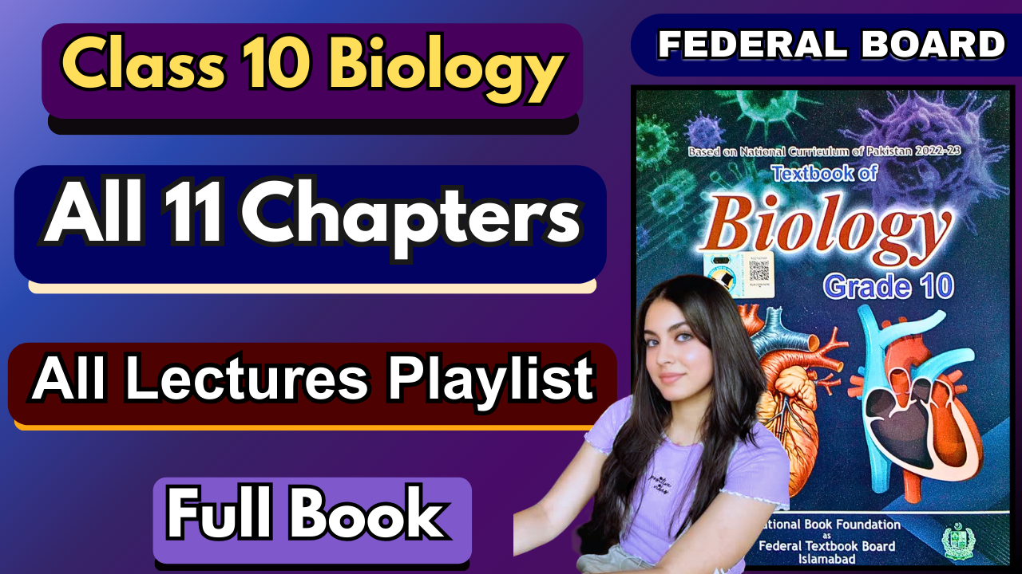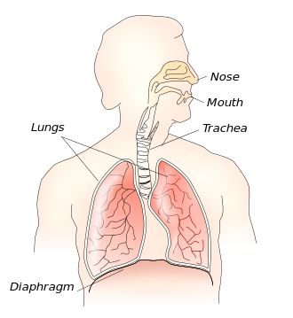

### **What is Respiration?**

* **Respiration** is the process by which cells obtain energy from glucose using oxygen.
* It involves a chemical reaction inside the cell, releasing energy needed for growth and other activities.
* **Aerobic respiration**: In the presence of oxygen, glucose is broken down into carbon dioxide and water, releasing energy.
* **Cellular respiration**: A series of chemical reactions inside the cell.

### **Breathing vs Respiration**

* **Breathing**: Physical movement of air into and out of the lungs.
* **Respiration**: Chemical reaction inside cells.

### **Function of the Respiratory System**

* Moves oxygen from the environment into the body.
* Removes carbon dioxide from the body.

## **3.1. Air Passage Way**

### **Gas Exchange in Humans**

* The main organs are the **lungs** and **air passages**.
* Air passages allow air to reach the lungs for gas exchange (oxygen intake and carbon dioxide release).
* Humans must have **moist, thin respiratory surfaces** for gas exchange.
* This exchange is called **gas exchange**.

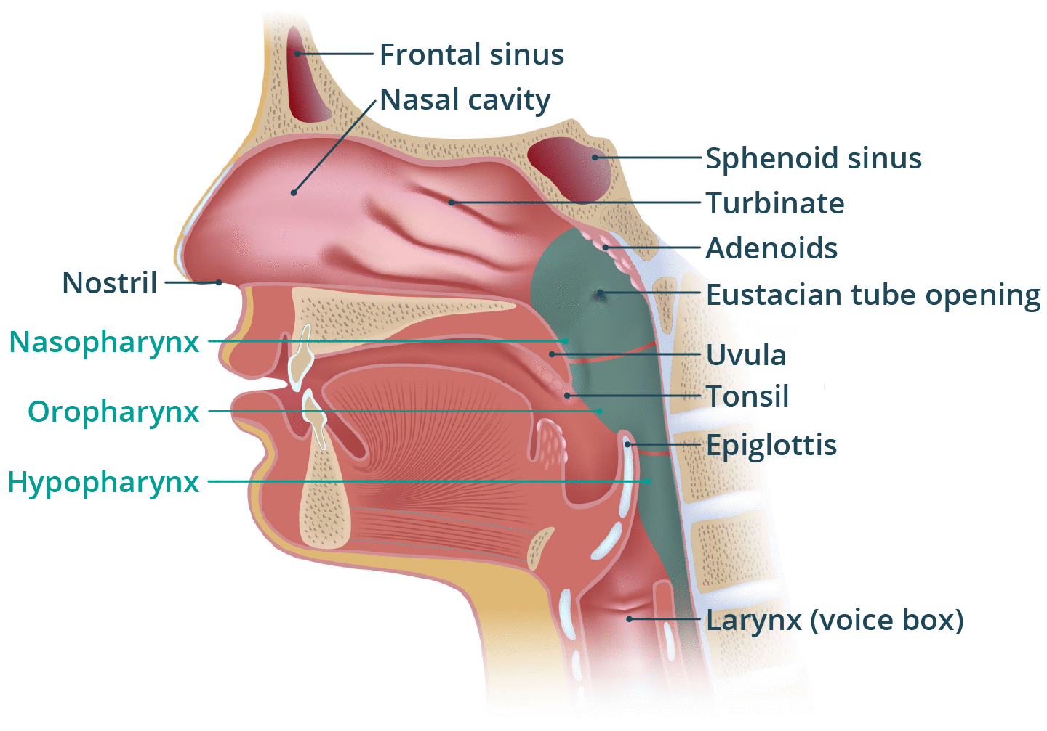

### **3.1.1. Air Passageway and Lungs**

1. **Nasal Cavity**
   * Filters, warms, and moistens the air.
   * Lined with **cilia** and **mucus** to trap dust and microbes.
   * Cilia move mucus toward the throat.
2. **Pharynx**
   * Common passage for air and food.
   * Located at the back of the mouth.
3. **Larynx (Voice Box)**
   * Cartilaginous structure.
   * Produces sound.
   * The opening is called the **glottis**, covered by the **epiglottis** during swallowing.

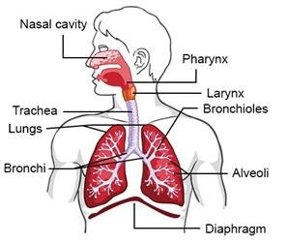

1. **Trachea (Windpipe)**
   * Extends from the larynx to the lungs.
   * Has **C-shaped cartilage rings** to keep it open.
   * Divides into two **bronchi**.
2. **Bronchi and Bronchioles**
   * Each bronchus enters a lung and divides into smaller **bronchioles**.
   * Bronchioles end in small air sacs called **alveoli**.
3. **Lungs**
   * Located in the thoracic cavity, protected by ribs and intercostal muscles.
   * Each lung is covered by **pleura** (a double membrane).
   * **Alveoli** provide a large surface area for gas exchange.

## **Structure and Function of Alveoli**

* **Alveoli**: Tiny balloon-like structures; grouped like grapes.
* Surrounded by **capillaries**.
* Moist inner surface helps in gas diffusion.

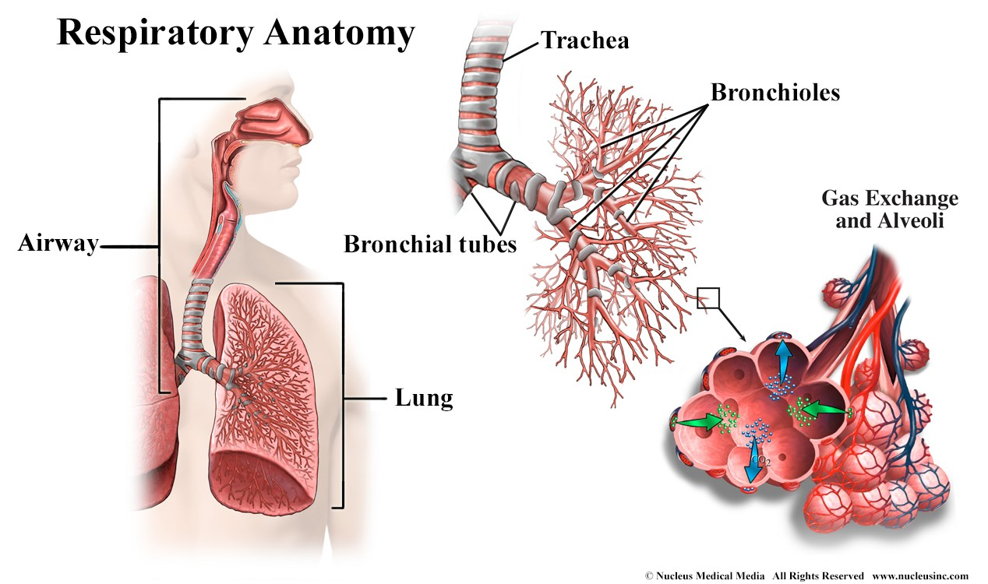

### **Gas Exchange Process**

* Oxygen in alveoli diffuses into blood capillaries.
* Carbon dioxide in the blood diffuses into the alveoli.
* **Diffusion**: Movement of gases across thin membranes due to concentration differences.

### **Structure and Function of Lungs**

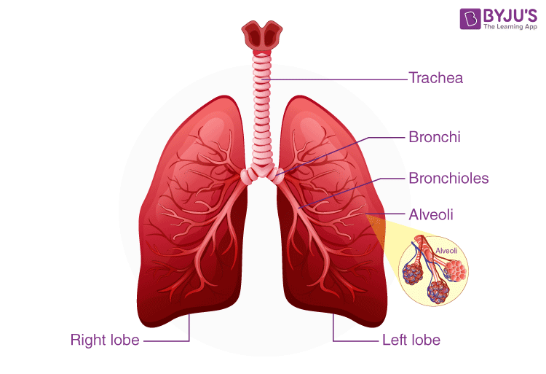

* **Location and Protection**:
  + Humans have two lungs, located in the **thoracic cavity** (on either side of the heart).
  + Protected by ribs and intercostal muscles.
  + Each lung is enclosed in a **double membrane** called the **pleura**.
    - **Pleura**: A thin fluid-filled space between two membranes that allows smooth gliding during breathing.
* **Alveoli – The Functional Units**:
  + Lungs have a **spongy texture** due to millions of **alveoli** (tiny air sacs).
  + Alveoli resemble **grape-like clusters** and increase the **surface area** for gas exchange.
  + Each alveolus is:
    - Surrounded by a network of **capillaries**.
    - Lined with **moisture** to help dissolve gases.

### **Gas Exchange in Alveoli**

* **Oxygen Movement**:
  + Oxygen dissolves in alveolar moisture.
  + It then **diffuses across thin alveolar walls** into the surrounding **capillaries** and enters the **red blood cells**.

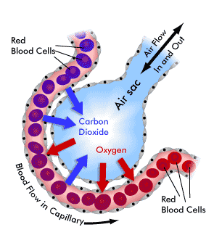

* **Carbon Dioxide Movement**:
  + CO₂ moves in the **opposite direction**: from blood to alveoli.
  + It **diffuses across the membrane** of the capillary into the alveolus and is **exhaled**.
* **Mechanism**:
  + **Gas exchange** occurs via **diffusion** across the **thin membranes** of alveoli and capillaries.

## **3.2. Mechanism of Breathing**

* Breathing is a **mechanical process** involving the movement of air in and out of the lungs.
* Lungs cannot move on their own – **muscles** (mainly the **diaphragm**) help.

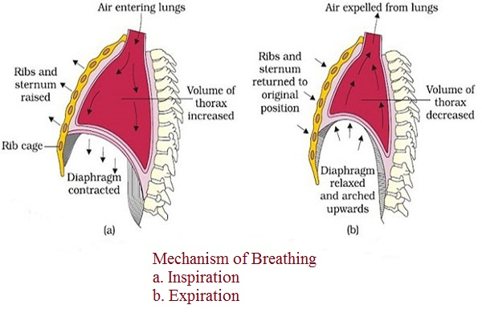

### **Steps in Breathing**

1. **Inhalation**
   * The diaphragm contracts and moves down.
   * Chest cavity enlarges → air is drawn into the lungs.
2. **Exhalation**
   * The diaphragm relaxes and moves up.
   * Chest cavity becomes smaller → air is pushed out of lungs.

## **Inhalation (Breathing In)**

### **Step-by-Step Process:**

1. **Diaphragm Contracts**
   * The diaphragm muscle **contracts** and moves **downwards**.
   * It changes from a **dome-shaped** to a **flattened** shape.
2. **Intercostal Muscles Contract**
   * The **external intercostal muscles** (located between the ribs) **contract**.
   * This pulls the **rib cage upwards and outwards**, expanding the chest cavity.
3. **Lung Expansion**
   * As the thoracic cavity expands, the **lungs expand** too.
   * The **volume of the lungs increases**, which causes the **pressure inside the lungs to decrease** (below atmospheric pressure).
4. **Air Intake**
   * Due to the low pressure inside the lungs, **air rushes in from the nose or mouth** into the lungs.

### **Result of Inhalation:**

* Lung Volume Increases
* Air is drawn into the lungs
* The diaphragm becomes flat

## **Exhalation (Breathing Out)**

### **Step-by-Step Process:**

1. **Diaphragm Relaxes**
   * The **diaphragm muscles relax**.
   * It returns to its **normal dome-shaped** position, reducing the chest cavity volume.
2. **Intercostal Muscles Relax**
   * The **external intercostal muscles relax**.
   * The **ribs move downward and inward**, further reducing the chest cavity volume.
3. **Lung Compression**
   * As the volume in the lungs decreases, the **pressure increases** (higher than atmospheric pressure).
4. **Air Expulsion**
   * The higher pressure in the lungs causes **air to be forced out** into the surrounding environment.

### **Result of Exhalation:**

* Lung Volume Decreases
* Air is pushed out of the lungs
* The diaphragm becomes dome-shaped

**3.3. Composition of Inspired and Expired Air**

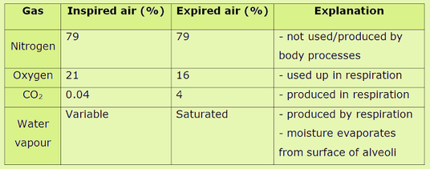

**3.4. Diseases Related to the Respiratory System**

### **Bronchitis** Bronchitis is the **inflammation of the lining** of the air passages, like the **trachea, bronchi, and bronchioles**.

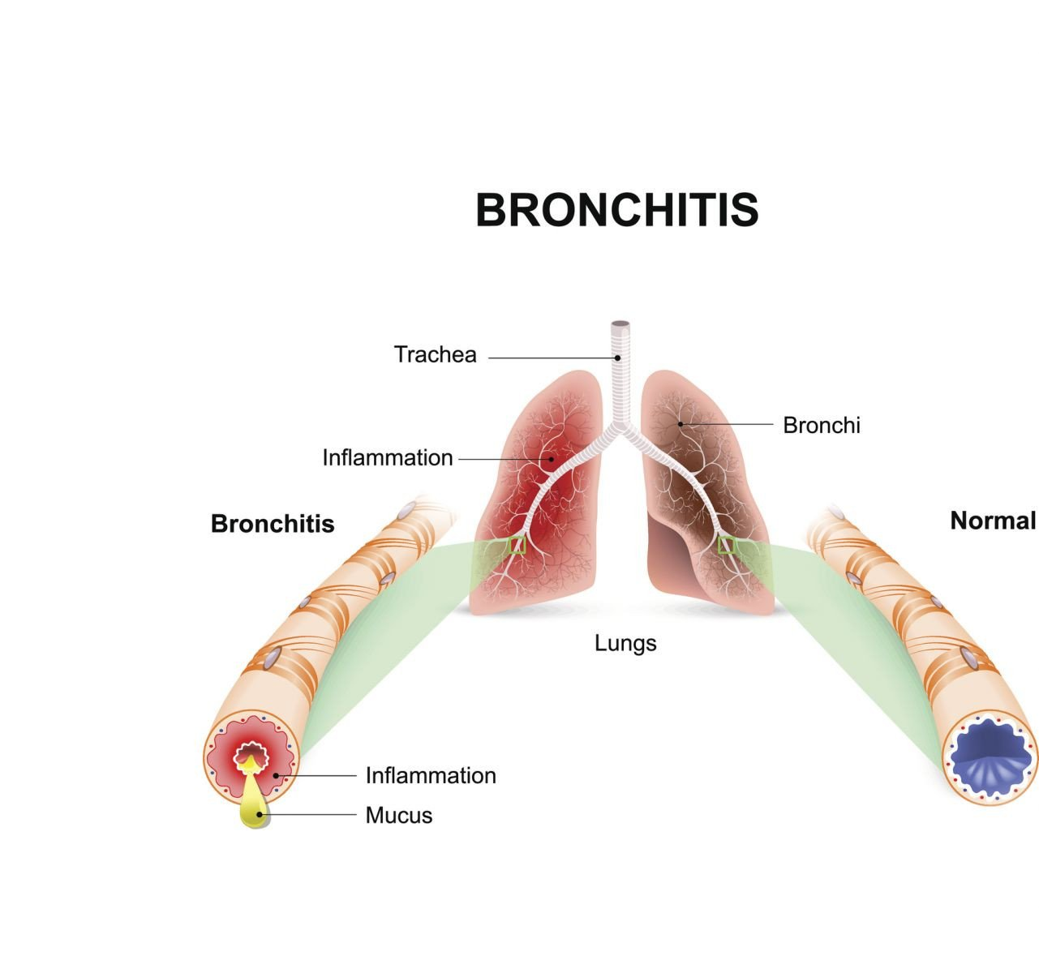

**Symptoms**:

* Excess mucus secretion from goblet cells
* Persistent cough with mucus
* Shortness of breath
* Breathing difficulties worsen as the disease progresses

**Types**:

* **Acute Bronchitis**:  
   Short-term inflammation due to infections (like the flu). Usually lasts a few days. (Cause: viral infections like the flu)
* **Chronic Bronchitis**:  
   Long-term conditions are mostly caused by smoking, air pollution, and industrial fumes. (Cause: smoking, air pollution, long-term exposure to irritants)

**Treatment**:

* Usually clears up in a week
* **Relief Tips**:
  1. Avoid smoking
  2. Drink plenty of fluids
  3. Take rest
  4. Take medicine if needed
* **Doctor consultation** is important if symptoms worsen

### **2) Emphysema:** A chronic respiratory disease where **alveoli** are **over-inflated and damaged**, losing elasticity.

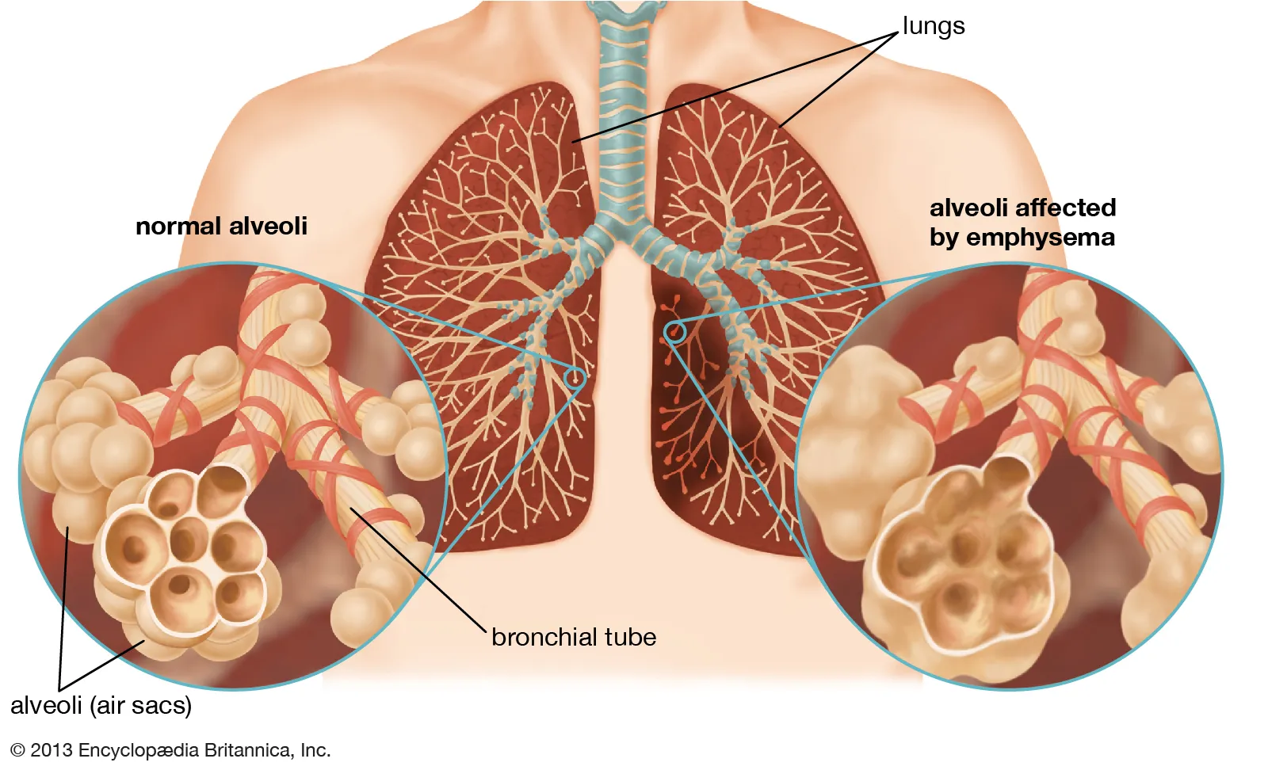

**Symptoms**:

* Shortness of breath
* Fatigue
* Difficulty in exhalation due to loss of elasticity

**Cause**:

* Gradual breakdown of alveolar walls
* Usually due to **long-term smoking**
* Air pollution and industrial irritants may contribute

**Effect on Lungs**:

* Reduced surface area for gas exchange
* Less oxygen absorption
* Air becomes trapped in the lungs

### **3) Pneumonia:** Inflammation of the alveoli caused by **acute infection** leads to fluid accumulation in the alveoli.

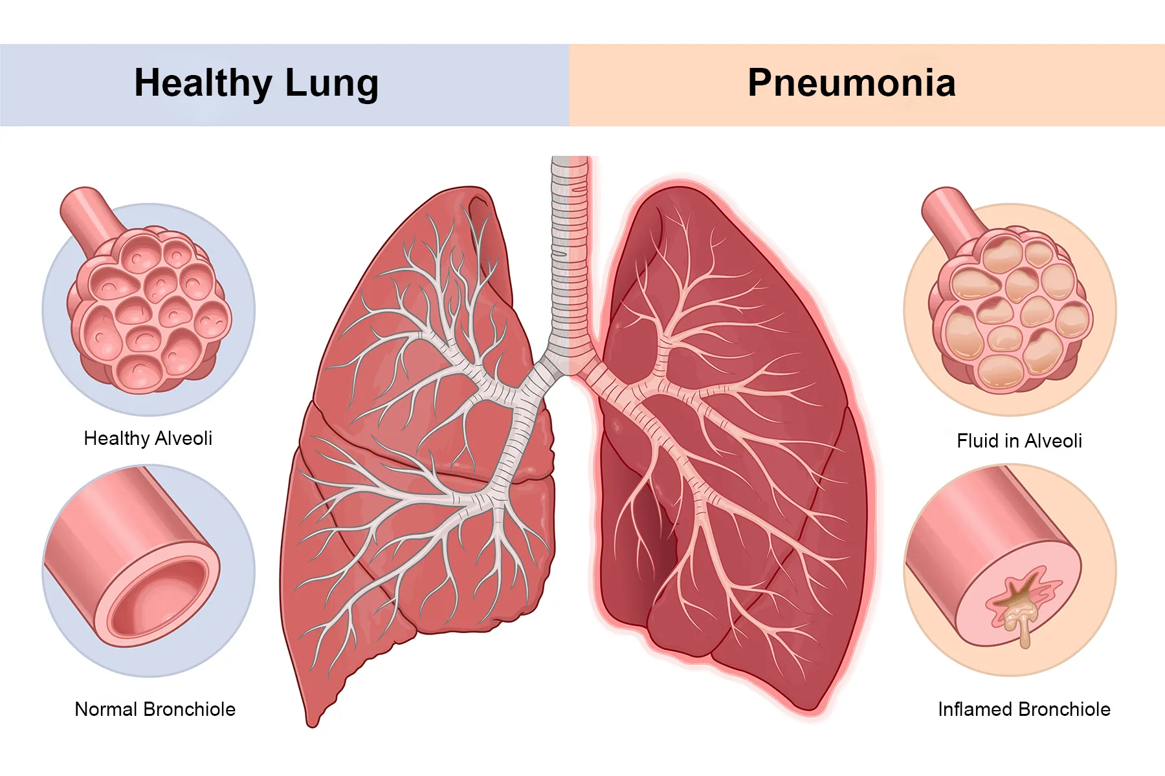

**Symptoms**:

* Fever
* Shaking chills
* Chest pain
* Cough
* Headache
* Sore throat
* Nausea
* Diarrhea

**Types**:

* **Double Pneumonia**: Both lungs are infected

**Cause**:

* Bacterial infection (commonly *Streptococcus pneumoniae*)

**Treatment**:

* Antibiotics for bacterial pneumonia

### **4) Asthma:** A chronic inflammatory disease of the airways triggered by allergens or irritants.

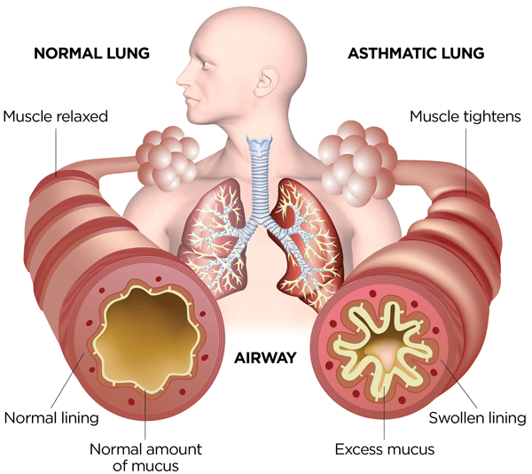

**Symptoms**:

* Wheezing (whistling sound)
* Difficulty in breathing
* Mucus secretion
* Swelling in the respiratory pathway

**Causes/Triggers**:

* Allergens: pollen, household dust, feathers, food
* Cold air
* Exercise
* Emotional stress
* Smoke

**Treatment**:

* **Mild asthma**: Inhalers with bronchodilators
* **Long-term asthma**: Treated with long-term control + quick-relief medicines
* Inhalers help dilate bronchioles and improve airflow

### **5) Lung Cancer:** Uncontrolled cell division in the lungs forms **tumours**. Starts in the **bronchiolar epithelium** and spreads.

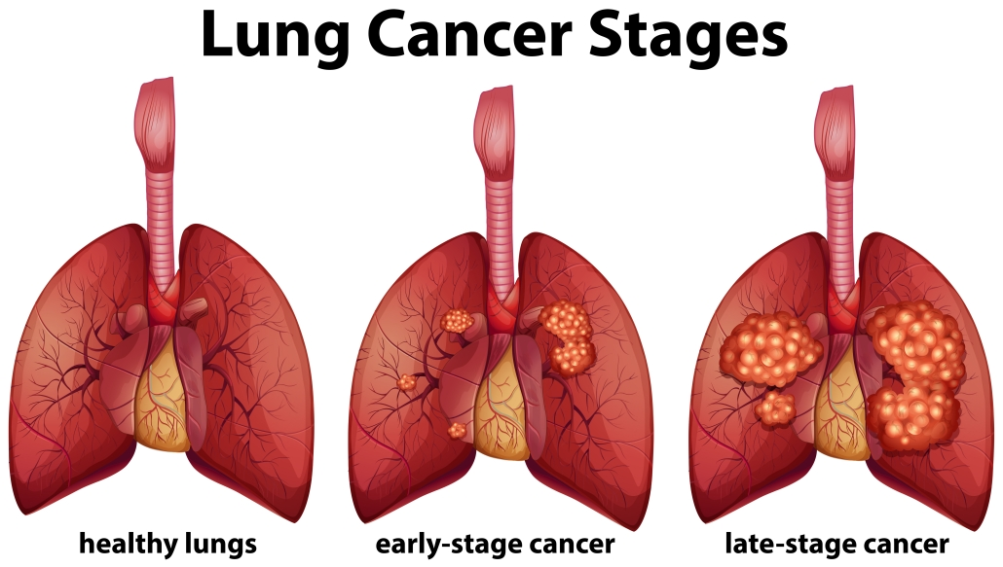

**Symptoms**:

1. Thickening and callusing of bronchial cells
2. Loss of cilia – dust accumulation
3. Tumour formation with cancerous cells
4. Metastasis – cancer spreads to other areas
5. The tumour blocks the bronchus, cutting off the air supply

**Cause**:

* Mainly due to **smoking**
* Long-term exposure to pollutants or carcinogens

**Impact**:

* Tumours reduce lung function
* Spread through the lungs and possibly to other body parts



